L-INK Taster
23 September 2023 10.30am – 2.30pm
Hatton Gallery
Work with artists, meet new people,
find out all about the L-INK 2023-24 project!
Registration Form

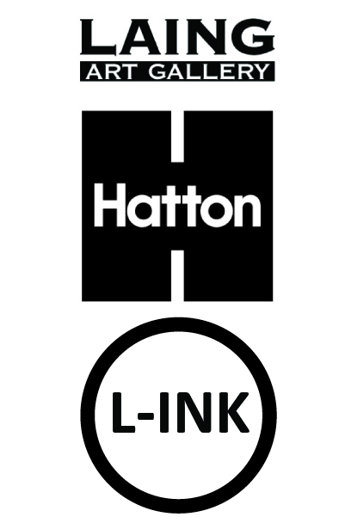
Your Details
(to be completed by all participants OR parent / guardian if the young person is under 18 years)
Participant surname

Participant forename

Participant preferred pronouns

How does the participant prefer to be addressed?

Participant date of Birth

Participant postal address | Postcode
Participant email address

Participant mobile number
Name of parent / guardian
(If participant is under 18)
Telephone number of parent / guardian  (If participant is under 18) | Home:  Mobile:
Can we contact the participant by text? | Yes / No (delete as appropriate)
Can we contact the participant via Instagram? | Yes / No (delete as appropriate)
Can the participant attend online Zoom workshops? | Yes / No (delete as appropriate)
Travel arrangement (i.e. how will the participant be travelling to the gallery? Ie train, bus, walk)

Does the participant have permission to leave the building unaccompanied? (If participant is under 18) | Yes / No (delete as appropriate)

Medical Information
(to be completed by parent / guardian if the young person is under 18 years)
Does the Young Person have asthma, fits or faints or any other allergy, illness or disability? | Yes/No  If yes, give details
Is the Young Person allergic to any medicine/ food/elastoplasts etc? | Yes/No  If yes, give details
Does the Young Person have any specific dietary requirements? | Yes/No
Name and address of the the Young Person’sdoctor

Is there any further information you think we should know? (Please continue on a separate sheet if necessary)

Signature

I would like to register myself / the young person in my care
(if participant is under 18 years; please delete as appropriate)

Name Please print ________________________________________________________________

Signed ____________________________________________________________________________

Date ______________________________________________________________________________

Relationship to child: _____________________________________________________________
(If applicable)

Emergency Contact telephone number(s) ____________________________________________

Please return this form to: learning@laingartgallery.org.uk

For further details of the L-INK 2023/24 project, please visit www.laingartgallery.org.uk
If you have any further queries, please contact:
zoe.allen@twmuseums.org.uk or learning@laingartgallery.org.uk

Adult and child consent form for photographic
and film usage
Photographs will be taken during the L-INK project for documentation and marketing purposes.
Please fill in this form to let us know your preferences.

This form must be completed before photography/video filming takes place.
Please read the points below before signing this form.
- I understand that Tyne & Wear Archives & Museums (TWAM) needs to take new photographs and
video film (images) in order to promote its work and that it asks for volunteers to appear in publicity
material for its projects and fundraising events.

- I hereby grant TWAM permission to use the images of the adult and child named below and to make
any reproductions or adaptations of the images for any purposes in relation to TWAM’s work including,
without limitation, the right to use them in any advertisements and other publicity materials (leaflets,
posters, publications), direct mail, books, presentations, newspapers, magazine articles, television
programmes, social media, websites and internet publications.

- I understand that it may be necessary for TWAM to share the images with its partner organisations to
the extent it reasonably considers necessary for the purposes of the work and activities referred to above.
We would like to share these images with [TWAM officer to insert names of organisations or delete point
3 if not applicable].

I understand that TWAM will keep all the images and use them for 3 years from the date of consent and
delete them once they are no longer appropriate.

- You can contact TWAM at any point and ask us not to use your photograph or film for any new purposes.
If you ask us not to use the photograph or film in future we will comply with your request. Remember
that once an article is published and in circulation (especially online) it may be copied and used by others.

You can read a full copy of our privacy notice on our website: www.twmuseums.org.uk/privacy-policy

Complete this form if this is about photography or filming of you and your child or a child or young person
you are responsible for.

Name ______________ (please print)
Email address:_________________________________________ Telephone:__________________________________
Being the parent of or person responsible for:
(1st child or young person’s name)
(2nd child or young person’s name)______________________________________
I hereby agree:
That my photograph / film and my child’s photograph / film or the photograph / film of the child or young
person for whom I am responsible, can be used to promote TWAM and can be reproduced.
That my permission is given to use my photograph / film and my child’s photograph / film, on condition that
my personal details and those of my child/children are not given to anyone unless I specifically give my permission in that regard. I understand that if I wish to withdraw permission for future use, I can contact TWAM at any time, although I understand that TWAM cannot withdraw images already published.

Signed Date ____

TWAM use only
Image name (use naming rules on guidance notes):
Venue photography taken at:
Event / exhibition:
Description of individuals in the photograph from left to right (hair colour, clothing):

Section/Team requesting permission:
Date received:

