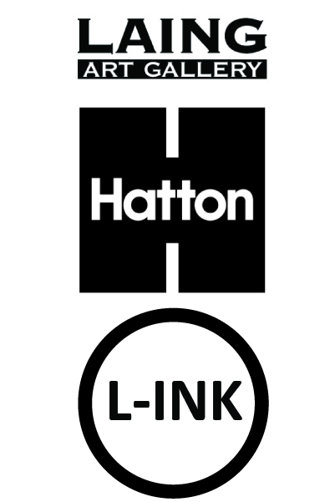
L-INK2025/26

Application Form
Please email your completed application form to learning@laingartgallery.org.uk
Personal Details
Please complete all sections
(to be completed by applicant OR parent / guardian of applicant if the young person is under 18 years)
Young Person surname

Young Person forename

Young Person preferred pronouns

How do you / the young person prefer to be addressed?

Young Person date of birth

Young Person postal address | Postcode:
Young Person email address

Young Person mobile number

Name of parent / guardian
(If Young Person is under 18)
Telephone number of parent / guardian
(If Young Person is under 18)
Can we contact you / the Young Person by text?

Can we contact you / the Young Person via WhatsApp?

Can the you / the Young Person attend online Zoom / Teams workshops?
Travel arrangement (i.e. how will the Young Person be travelling to the gallery? Ie train, bus, walk)
Does the Young Person have permission to leave the building unaccompanied? (If participant is under 18)

About You (to be completed by the young person who is applying to L-INK)
Please use this space in any way, to tell us about yourself and why you are interested in joining L-INK.
(No more than 500 words, please feel welcome to include use images & links to your website if you have one)

Medical Information
(to be completed by parent / guardian if the young person is under 18 years)
Does the young person have asthma, fits or faints or any other allergy, illness or disability? | Yes / No (please delete as appropriate)  If yes, please give details
Is the young person allergic to any medicine/food/elastoplasts etc? | Yes / No (please delete as appropriate)  If yes, please give details
Does the young person have any specific dietary requirements? | Yes / No (please delete as appropriate)  If yes, please give details
Name and address of the young person’s doctor | Yes / No (please delete as appropriate)  If yes, please give details

IMPORTANT INFORMATION to read before signing
L-INK meet once each month, (unless stated). L-INK is a fixed-term project and we ask for a time
commitment of approximately one day per month plus one potential overnight trip to visit other
galleries during the Summer. We understand that participants have many extra-curricular commitments
and responsibilities as well as school, college or University work, so if participants find that they are
unable to commit to the project, please let us know so that we can offer places to others.

Signature

Name (Please print) ____ ________________________________________________________
(Parent / Guardian to sign if applicant is under 18 years)

Signed _______________________________________________________________________

Date _________________________________________________________________________

Relationship to child: ___________________________________________________________
(If applicable)

Emergency Contact telephone number(s) ___________________________________________
Please provide this information even if young person is over 18

Additional numbers to be contacted in an emergency

Name ______________________________________________________________________

Relationship ________________ __________________________________________________

Contact telephone number(s) _____________________________________________________

Any other information you think we should know:

_______________________________________________________________________________

_______________________________________________________________________________

_______________________________________________________________________________

Please return this form by Monday 13 October 2025, 17.00 to: learning@laingartgallery.org.uk

For further details of the L-INK2021 project, please visit www.laingartgallery.org.uk
If you have any further queries, please contact: learning@laingartgallery.org.uk

Adult and child consent form for photographic
and film usage
Photographs will be taken during the L-INK project for documentation and marketing purposes.
Please fill in this form to let us know your preferences.

This form must be completed before photography/video filming takes place.
Please read the points below before signing this form.
- I understand that North East Museums (NEM) needs to take new photographs and
video film (images) in order to promote its work and that it asks for volunteers to appear in publicity
material for its projects and fundraising events.

- I hereby grant NEM permission to use the images of the adult and child named below and to make
any reproductions or adaptations of the images for any purposes in relation to NEM’S work including,
without limitation, the right to use them in any advertisements and other publicity materials (leaflets,
posters, publications), direct mail, books, presentations, newspapers, magazine articles, television
programmes, social media, websites and internet publications.

- I understand that it may be necessary for NEM to share the images with its partner organisations to
the extent it reasonably considers necessary for the purposes of the work and activities referred to above.
We would like to share these images with [NEM officer to insert names of organisations or delete point
3 if not applicable].

I understand that NEM will keep all the images and use them for 3 years from the date of consent and
delete them once they are no longer appropriate.

- You can contact NEM at any point and ask us not to use your photograph or film for any new purposes.
If you ask us not to use the photograph or film in future we will comply with your request. Remember
that once an article is published and in circulation (especially online) it may be copied and used by others.

You can read a full copy of our privacy notice on our website: www.northeastmuseums.org.uk/privacy-policy

Complete this form if this is about photography or filming of you and your child or a child or young person
you are responsible for.

Name ______________________ ______________ (please print)
Email address __________________________________ Telephone:_________________ _______________
Being the parent of or person responsible for:
(1st child or young person’s name) ____________________________________________ _______
(2nd child or young person’s name____________________________________________ _______
I hereby agree:
That my photograph / film and my child’s photograph / film or the photograph / film of the child or young
person for whom I am responsible, can be used to promote NEM and can be reproduced.
That my permission is given to use my photograph / film and my child’s photograph / film, on condition that
my personal details and those of my child/children are not given to anyone unless I specifically give my permission
in that regard. I understand that if I wish to withdraw permission for future use, I can contact NEM at any time,
although I understand that NEM cannot withdraw images already published.

Signed _____ Date ____

NEM use only
Image name (use naming rules on guidance notes):
Venue photography taken at:
Event / exhibition:
Description of individuals in the photograph from left to right (hair colour, clothing):

Section/Team requesting permission:
Date received:

