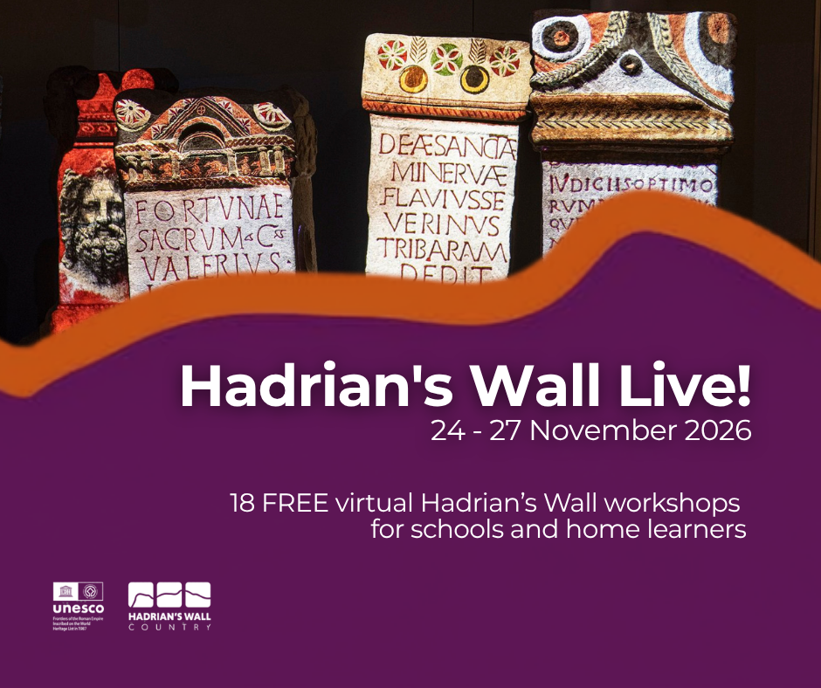
In this document, you will find each date listed separately. Each session has a quick guide theme, and then a more detailed description. You can book as many or as few sessions. If you aren’t sure which sessions to book, then please get in touch with us on learning@greatnorthmuseum.org.uk
Find out more about our workshops and then book your spaces here: https://www.northeastmuseums.org.uk/greatnorthmuseum/whats-on/hadrian-s-wall-virtual-focus-day

TUESDAY 24 NOVEMBER 2026
TUESDAY 24 NOVEMBER | Facilitator | Theme
9.30 - 10am | Vindolanda Trust | Shoes/Climate
10.10am - 10.40am | Tullie Museum and Art Gallery | Native Britains vs the Romans
10.50am - 11.20am | Binchester Roman Fort | Maintenance and defense of Hadrian’s Wall and Dere Street
11.30am - 12noon | James Gerrard from Newcastle University | Coin Hoards, treasure

9.30am - 10am
Daily Life on the Roman Frontier at Magna Fort with the Vindolanda Trust
Learn about the Roman fort of Magna, built along the line of Hadrian's Wall, and discover what daily life was really like for the soldiers stationed there. Where in the Roman Empire did they come from, and what daily duties did they have to complete in the fort? Along the way, you'll learn about real objects from the collection, earn Roman coin (denarii) for every right answer, and find out what your coins could buy you at the fort at the end!
Suitable for all KS2 year groups, but better for year 3 and 4.
10.10am - 10.40am
Choose Your Champion! Romans vs. Britons with Tullie Museum and Art Gallery
Romans or Native Britons - whose side of the wall are you on? Join Tullie for an interactive, live session as two characters from the past go head-to-head in gameshow fashion to prove to their audience whose way of life is best. Packed full of humour, real artefacts, and audience challenges, this fun and engaging event explores life on Hadrian's Wall for the natives and Romans who called it home. There’s no sitting on the wall in this game of debate, so get ready to CHOOSE YOUR CHAMPION!
10.50am until 11.20am
City of the Brigantes, Stronghold of the Romans with Binchester Roman Fort
Binchester Roman Fort was the largest, and one of the most powerful, military installations in Northern England. It played a pivotal role in protecting the Northern Frontier Zone of the Roman Empire. If it weren't for Binchester, Hadrian's Wall may never have been built.
Learn more about Binchester and its range of elite troops in our immersive workshop, featuring videos and reconstructions of the fort.
This session ran last year and schools said ‘We thoroughly enjoyed the Binchester session. The leaders really brought humour to it all and the children really enjoyed it. But all sessions linked to local areas and brought the Roman topic to life.’

11.30am until 12noon
Roman hoards from Hadrian's Wall and Beyond with James Gerrard from Newcastle University
In this session we will consider what makes a Roman hoard and the many reasons why they ended up in the the archaeological record. Examples will include coin hoards and hoards of the objects
Better for upper KS2

WEDNESDAY 25 NOVEMBER 2026
WEDNESDAY 25 NOVEMBER | Facilitator | Theme
9.30 - 10am | English Heritage | Hoards, Source material
10.10am - 10.40am | Segedunum Roman Fort | Bathhouses
10.50am - 11.20am | Time Machine Designs | Digital flyover
11.30am - 12noon | Durham University - Archaeology | Mithriasm, religion, gods
1.15pm -1.45pm | Vindolanda Trust | Q&A with an Archaeologist

9.30am - 10am
The Mysteries of Corbridge Roman Town with the English Heritage
Learners will use detective skills to think critically about some of the curious artefacts found at Corbridge Roman Town, including the intriguing Dodecahedron, Face pots, and the Corbridge Hoard. Helping young people to understand how our knowledge of the past is constructed from a range of sources.

10.10am - 10.40am
Bathing at the Frontier with Segedunum Roman Fort
Bathhouses were an important part of Roman Identity and were present throughout the Roman Empire, even at Hadrian’s Wall. Join us at Segedunum, Hadrian’s Walls most easterly fort to look at the remains we have here, what bathhouses were like, and why they were such an important part of Roman Life!
10.50am until 11.20am
Hadrian’s Wall 180 – a time travel experience with Time Machine Designs
This session will take you on a journey along Hadrian’s Wall as it is thought to have appeared in the year 180CE. Time Machine Designs has created the world’s first complete reconstruction of the Hadrian’s Wall system using historical and archaeological research, 3D modelling software and Microsoft’s Flight Simulator game. By the end of the session you will have seen Hadrian’s Wall from the air and how it fitted into the landscape, learned about its turrets, milecastles, forts, villages and harbours and seen whose houses would have been demolished by the Romans!
11.30am until 12noon
How to Remember a Mystery with Durham University
This session is about how the worship of the god Mithras spread through the Roman World without his worshippers writing anything down. After you've been introduced to Mithras, how much can you remember to pass onto the next potential worshipper?
Best for year 5 and 6
1.15pm until 1.45pm
Meet an Archaeologist with Vindolanda Trust
Meet Rachel Frame, Senior Archaeologist with the Vindolanda Trust and find out what a working archaeologist gets up to along Hadrian’s Wall. Rachel will tell you a bit about her career journey and current role and then will spend some time answering your questions.
Due to the number of attendees at these sessions, we ask questions to be submitted in advance. Please email any questions that your students have about working as an archaeologist to us by November 13. We will then endeavor to answer as many as possible during the session.

THURSDAY 26 NOVEMBER 2026
THURSDAY 26 NOVEMBER | Facilitator | Theme
9.30 - 10am | Durham University Museums | Words, diploma
10.10am - 10.40am | Open University | Clothing and Class
10.50am - 11.20am | Classics for All NE | Word Roots
11.30am - 12noon | York Museums | Iron Age/Roman York
1.15pm -1.45pm | Classics for All East MIdlands | Roman Britain Inscriptions

9.30am - 10am
Mystery of the Lanchester Diploma with the Durham University Museums
The Mystery of The Lanchester Diploma: In this session students will decode the secrets of one of the most enigmatic and fascinating objects in Durham University’s Museum of Archaeology collection; The Lanchester Diploma. Students will pick out clues hidden in the Latin text of this remarkable artefact to try and find out its story. Will your class be able to solve the mystery of the Lanchester Diploma and learn more about the lives of those who lived in the forts supporting Hadrian’s Wall?
10.10am - 10.40am
Roman dress with the Open University
What was a toga, and why is it considered such an icon of Roman culture? What else did people wear? And what did the soldiers and other people wear on Hadrian’s Wall, where it was so much colder than in Italy? This session will introduce to some of the clothing styles people in the Roman Empire wore, and how dress was used to mark gender roles, status groups and life stages, including the transition from childhood to adulthood.
10.50am until 11.20am
What does Hadrian’s Wall have to do with the English language? More than you might think! with Classics for All: North East
This interactive session uses the story of Hadrian’s Wall - the activities that happened there and the roles that soldiers would have played - as an accessible and engaging way into understanding English vocabulary, word structure, and meaning. Rather than focusing on history alone, it helps pupils see how many everyday English words are built from Latin roots and helps them spot patterns that help unlock the meanings of hundreds of new words and boost their linguistic skill set.
11.30am until 12noon
From Chariots to Mosaics with York Museums Trust
In this session, pupils will explore the Yorkshire Museum to discover what life in the north of Iron Age Britain was like, and how things changed after the Romans arrived in the place we now know as York.

1.15pm until 1.45pm
Decoding Roman Inscriptions from Hadrian's Wall with Classics for All: East Midlands and Roman Inscriptions of Britain online.
This session will introduce pupils to decoding Roman inscriptions (no Latin required). Pupils will investigate the idea of writing as a new technology brought into Britain by the Romans and get the chance to hear diverse voices from Roman Britain.

FRIDAY 27 NOVEMBER 2026
FRIDAY 27 NOVEMBER | Facilitator | Theme
9.30 - 10am | Roman Carlisle | Choose your own adventure
10.10am - 10.40am | Northumberland National Park | Caring for the Wall
10.50am - 11.20am | Newcastle University | Roman Mathematics
11.30am - 12noon | Historic Environment Scotland | Antonine Wall, Childhood

9.30am - 10am
Lost ghosts of the Roman Temple with Uncovering Roman Carlisle
Join the Uncovering Roman Carlisle team in this choose your own adventure! Get your trowels at the ready as you jump through time to piece together the stories of the Roman ghosts in a temple once lost to time... until now!
Better for upper KS2, but works for all KS2
10.10am - 10.40am
Caring for Hadrian’s Wall with Northumberland National Park
The landscape of Northumberland around Hadrian’s Wall is one of the most visited places in the county, welcoming thousands of visitors every year, as well as being home to a diverse selection of wildlife. So how do we protect and conserve both the archaeology and the unique habitats, as well as look after the people who visit? In this session you will discover why the Romans chose this area to build Hadrian’s Wall, find out about the different job roles at Northumberland National Park that care for the history and the landscape, and what skills are needed for these types of green careers.
10.50am until 11.20am
Counting on Hadrian's Wall with Newcastle University
How did the Romans do maths? Is everything your teachers tell you about Roman numerals wrong? In this new and improved interactive session based on the cutting-edge research of the AgRoMa project, we’ll find out how the Romans counted and calculated using real ancient textbooks. On the way, we’ll also be helping out the Emperor Hadrian. Will his thirst for wall-building bankrupt Rome?
This session ran in 2025 and schools said ‘The maths one was very engaging, giving the children lots of chances to actively take part.’
11.30am until 12noon
Children of the Antonine Wall with Historic Environment Scotland
You will have heard of Hadrian’s Wall in England, but the Romans also marched into Scotland and built another frontier defence, known as the Antonine Wall. We will explore what life was like in Roman Scotland, in particular the lives of two children who we know lived there. The session will include some explanation of the Antonine Wall, talk about two children who lived on the Wall, an independent exercise, and chance to feedback on the exercise to the rest of the group

