Stone Age to Iron Age explorers

These resources have been created to help your group explore the Ice Age to Iron Age gallery at the Great North Museum: Hancock.

The activities include:
- Object Eye Spy
- Elk investigations
- Measuring the past
- Map the Ice Age to Iron Age gallery
- The BIG Question

If you have any suggestions on other resources, we can create that would support your groups learning or if you would like to share any of your work with the museum then please email learning@greatnorthmuseum.org.uk

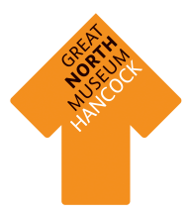


Object Eye Spy

Find all these objects in the Ice Age to Iron Age gallery and write what they are called beneath them.
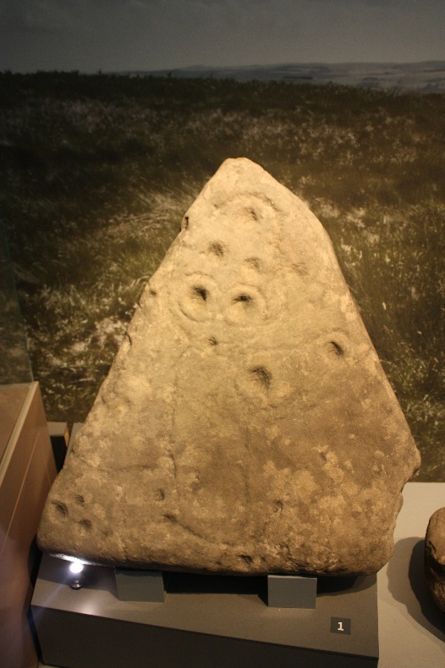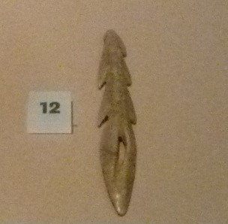


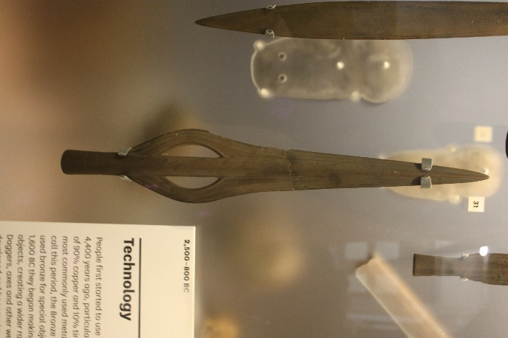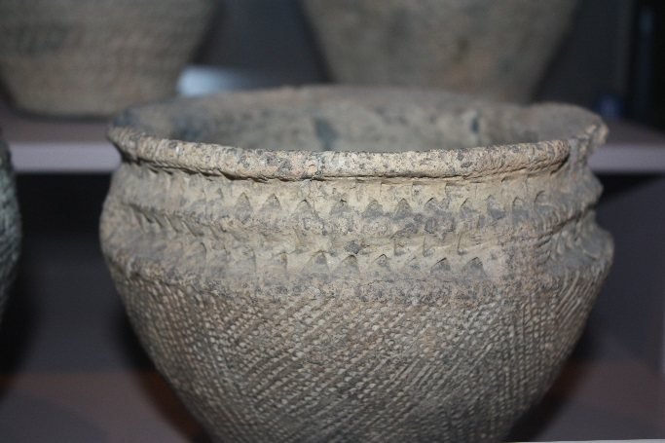

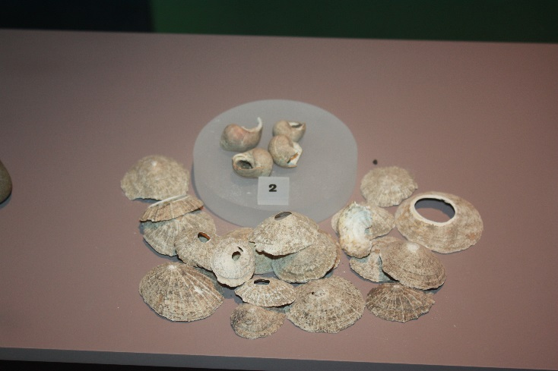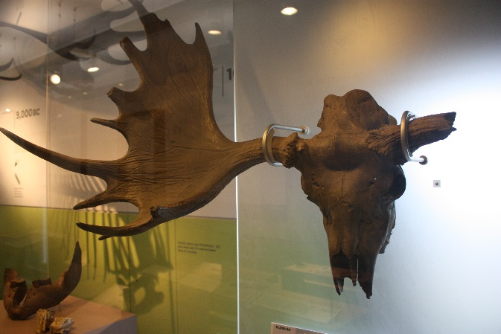

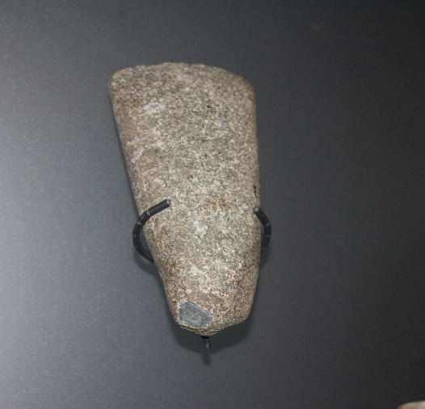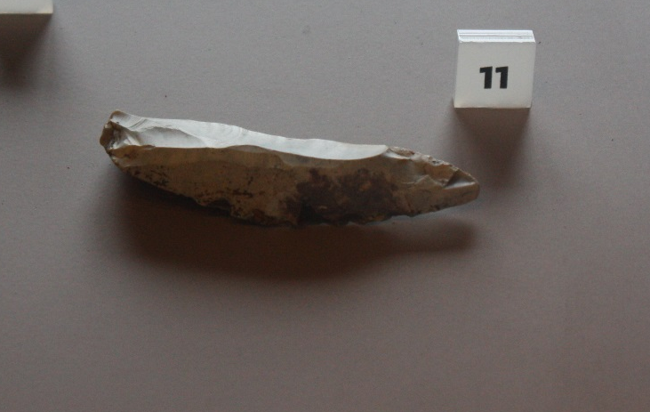

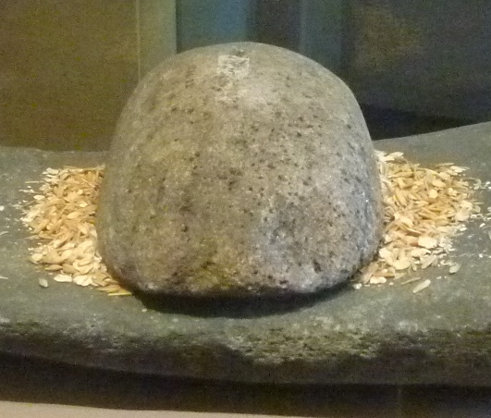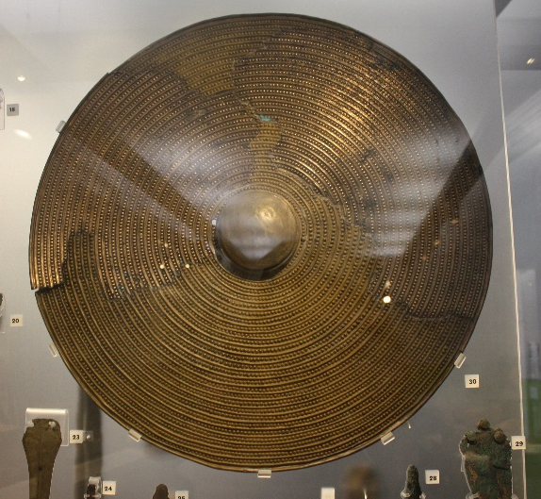

Elk Investigations
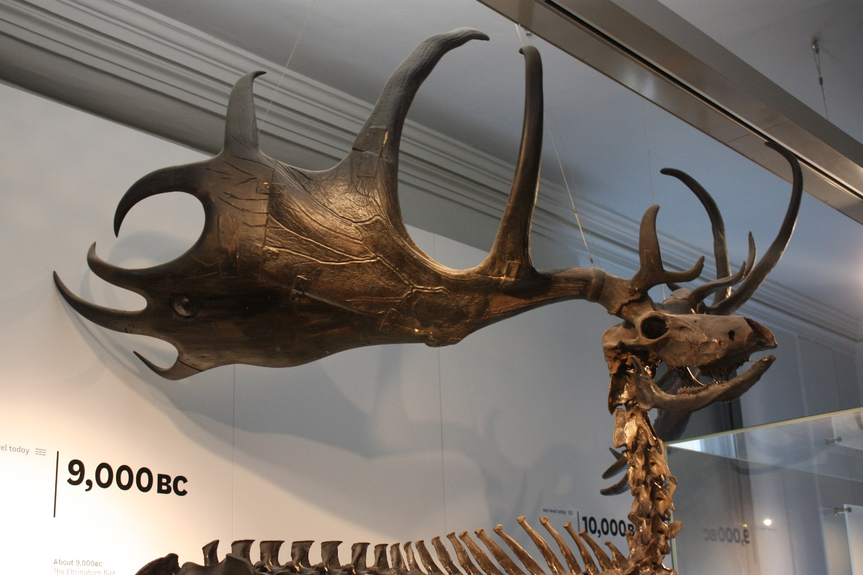
Hunter Gatherers in the Stone Age would hunt deer and elk to help them survive. You would need to be very skilled to bring down an elk this size.
When you caught the elk you would not let any of it go to waste.
What could you the following parts for:
Bones –

Fur –

Flesh –

Antlers -

Sinew (tendons/ligaments)-

Measuring the Past

Objects are very important in helping us to understand life from the Stone Age to the Iron Age. Which objects survive over time depends on what material they are made from.
Count the number of objects made from each type of material in five cases.
Type of material | Tally of objects made from this material | Total
Earth Materials: stone, pottery, terracotta, clay, bronze, iron, gold, silver.
Animal materials: wool, cloth, ivory, leather, skin, bone.
Plant materials: linen cloth, wood, flowers, reeds.

Circle the type of material that has survived the best.
Earth Animal Plant
Why do you think this is?

Circle the type of material that has survived the worst.
Earth Animal Plant

Why do you think this is?

Choose a starting point and an end point in the Ice Age to Iron Age gallery. Draw your favourite objects on the route, remember to label what they are.

Make it your own!
Map the Ice Age to Iron Age gallery

A BIG Question

Were people who lived in the Stone Age intelligent?

Note – there is no right or wrong answer to this question. If you and friends disagree then try and persuade each other with good reasoning why your answer is the strongest with evidence.

