Exploring religion (past and present)
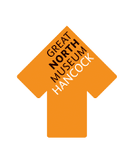

Explore the museum to find out about different religious beliefs. Some religions are still followed today whereas others are no longer believed in but they all have stories to tell about faith and their values.

This resource has been created for Key Stage 1 and 2 children and has been designed to be used to start discussions about different objects in the museum.

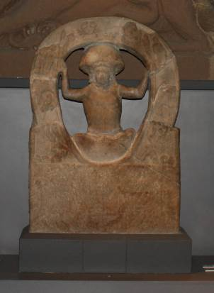
This object shows the birth of Mithras (a Persian god worshipped by the Romans) from the cosmic egg.
Can you find this object in the Anglo Saxons gallery on the ground floor?

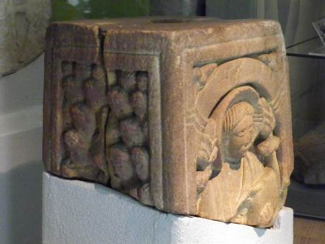

This object is called the Rothbury Cross and was made over 1000 years ago (800 – 850 AD). You can see another part of the Rothbury Cross on display next to it.

What images can you see on the Cross?

Have you got any ideas which religion it is from?

This object is from the Christian religion. It shows the crucifixion as well as Christ holding a book, crowds of people and animals.

Can you find this object in the Hadrian’s Wall gallery on the ground floor?

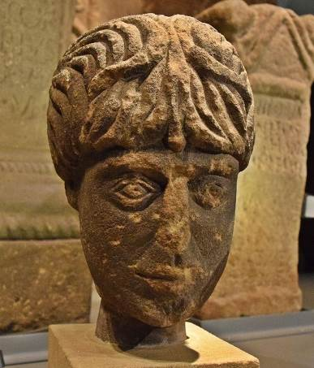

This is the head of the god Antenociticus from Benwell. Before the Romans brought Christianity to Britain a large number of different pagan gods were worshipped. Antenociticus was a local god from Benwell, who was adopted and worshipped by the Roman soldiers who were stationed at Benwell fort.

Can you find examples of any different gods in the Hadrian’s Wall gallery?

Can you find this object in the Egyptian gallery on the first floor?

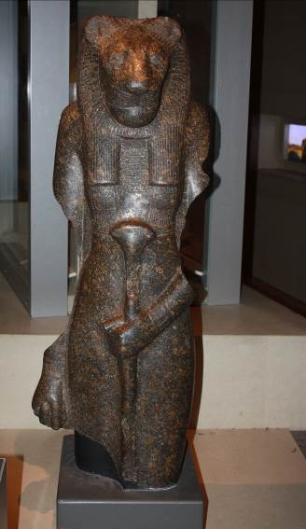

This is a statue of the goddess Sekhmet from ancient Egypt. The Egyptians were polytheists (they believed in many different gods) but she was known as the warrior goddess. The Egyptians usually showed their gods with animal heads.

Why do you think they chose a lioness for Sekhmet?

Can you find this object in the Shefton (Greek) gallery on the first floor?

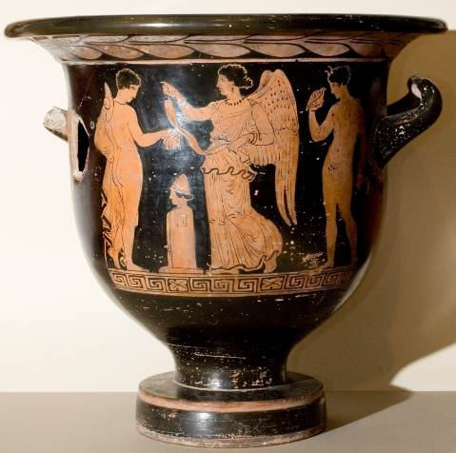

The person in the middle of this vase is Nike, the Greek goddess of Victory (in the Roman World she was called Victoria). The Greeks believed in many different gods and goddesses like the Egyptians and the Romans.

Look at the pot carefully, what do you think is happening in the scene?

Can you find this object in the World Cultures gallery on the first floor?

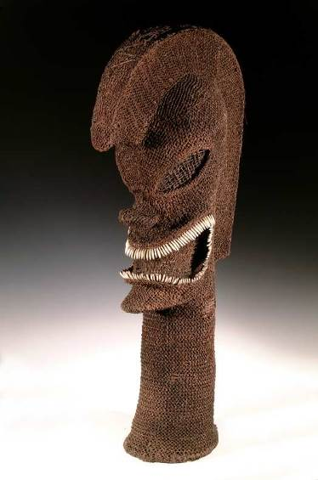

We think that this is a statue is of the Polynesian god for war and it is 300 years old. The statue is made from wicker and dog’s teeth.

How is it different from Sekhmet the Egyptian goddess of war (look at the third picture in your booklet)?

Can you find this object in the World Cultures gallery on the first floor?

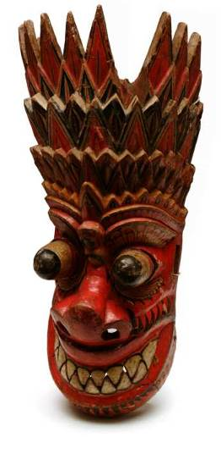

This is a painted wooden mask used in Buddhist dances (before 1950) to cure illnesses. How do you think you would feel if your doctor wore this?

Can you find this object in the World Cultures gallery on the first floor?

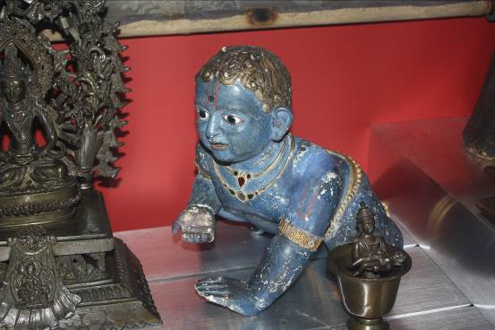

This is a statue of Krishna, the living form of Vishnu (one of the Hindu gods) as a baby. What other Hinduist objects can you find in the display case?

Have a look in the rest of the case, can you find objects from the following religions:

- Islam
- Local African religions
- Daoism

