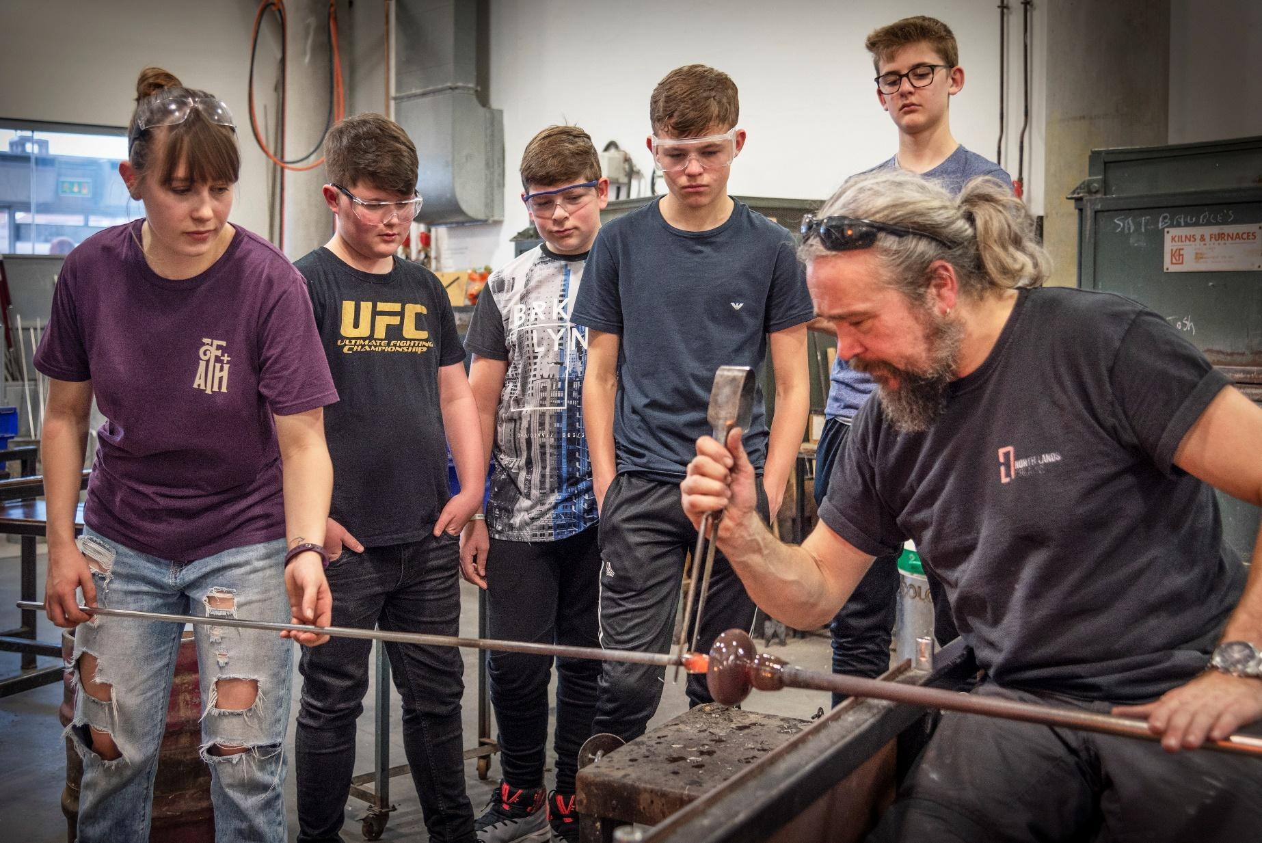

**DesignLab Nation Newcastle/ Gateshead - Call out for designer/artist/maker**

North East Museums (Shipley Art Gallery) are collaborating with designers and local schools as part of DesignLab Nation, a national school’s programme led by the Victoria and Albert Museum, London. **We are looking to recruit an innovative designer/artist/maker to lead exciting design projects with Secondary school students and teachers based in the Newcastle/ Gateshead area between September 2025 and August 2026.** This designer will work with up to three Newcastle/Gateshead based Secondary schools on exciting in-depth design projects focussing on the theme of **Ceramics.**

The selected designer will set a design challenge for students, which they will then work towards solving through four creative full day sessions. With support from museum teams from Shipley Art Gallery (Gateshead) and the V&A, the designer will plan a series of focussed workshops, highlighting key stages of a designer’s journey including finding inspiration, writing a brief, experimentation, prototyping, and presentation. Sessions should involve creative thinking, critical thinking, and collaborative activities, as well as interactive talks, demonstrations, and supportive feedback crits. Students and teachers will be encouraged to take inspiration from objects and collections at V&A and Shipley Art Gallery.

The selected designer will also be asked to support with several Teacher CPD and celebration events throughout the academic year, as well as participate in planning meetings and contribute to evaluation.

**Criteria for designers**

**Essential:**

* Works as a practicing designer/artist/maker who is passionate about design and Newcastle/ Gateshead’s design heritage. We are particularly interested in hearing from designers/makers/artists with an interest in chairs/seating/ 3-D design/ sculpture
* Able to inspire the next generation of designers, makers, and innovators, ready to encourage them to learn about and engage with contemporary design and industrial heritage.
* Experience in leading creative workshops with schools, young people, or similar groups.
* Able to make links between their own design practice and the collection of chairs at Shipley Art Gallery. This may be through materials, technical processes, or design thinking/ approach. We are keen to work with designers from different areas of the design industry. [Our collections | Shipley Art Gallery](https://shipleyartgallery.org.uk/collections/our-collections)
* Organised, and able to project plan and schedule accordingly.
* Able to champion sustainable design practice.
* Prepared to support evaluation, documentation, and reporting as required.
* Willing to undertake a satisfactory Enhanced DBS Disclosure will be required prior to taking up appointment of this role. Comply with North East Museums and V&A guidelines for safeguarding, health and safety and undertake training.

**Desirable:**

* Ideally works, lives, or has links to the Newcastle/Gateshead area. Where possible the selected designer must be willing to travel regularly to and around the area over the course of the project.
* Has an up-to-date knowledge of the 2017 D&T syllabus.
* Experience in working with teachers/educators, and able to work with teachers to share skills and develop new approaches to teaching design.
* Awareness of differentiating teaching styles to communicate with a variety of students.

**Designer Indicative Timeline**

**July/August 2025:** Recruit designer

**September 2025:** Planning and preparation

**October 2025:** Teacher Development Strand CPD- 2 x full day sessions (=1 day at Shipley Art Gallery, Gateshead & 1 day at V&A)

**November 2025- July 2026:** Project Delivery- 3 school projects- each with 4 sessions each (1 day V&A, 3 in Newcastle/ Gateshead)

**July 2026:** Wider Teacher CPD delivery (TBC), End of project celebration/ Student Display

**July/August 2026:** Designer contributes to dissemination and evaluation

**Fees**

**Teachers Development Strand- Early Autumn term 2025**

Lead 2 x creative sessions @ £240 each= £480

Planning and preparation 2 x days @ £240 each= £480

**School projects- Autumn 2025, Spring 2026 and Summer term 2026**

3x DLN school projects

The fees for each school project are:

Lead 4 x creative session @ £240 each= £960

Planning and preparation 3 x days @ £240 each= £720

**If you were to deliver all three school projects the total fee would be: Total: £5040.00**

**Regional CPD and Celebration- Summer term 2025**

* + - * 2 x £240 for the Lead Designer to lead a workshop at the Teachers Regional CPD, including 1 day planning= £480 – please note this event is tbc.
      * 1.5 x £240 for the Lead Designer to lead a workshop at the Celebration event and contribute to the Student Display= £360

***Overall total: £6840.00***

**Other Budget**

* There will then be approx. £200 material budget for each school project and £50 per Teachers CPD/workshop.
* The designer will also be consulted on the budget for Teacher’s Development Strand, Teacher’s Regional CPD and Celebration Event/Student Display.
* For trips to the V&A, London the designer will have travel paid for them to support the visit. We are happy to review reimbursing for designers visiting schools or partner museums and creative organisations where necessary.

**Programme Overview**   
Creative education has the power to change and shape young people’s lives for the better, and today, the creative industries are worth over £10 million per hour to the UK economy. However, design education across the UK is in crisis and a damaging skills gap is increasingly apparent.

The V&A’s national schools programme- **DesignLab Nation**- aims to inspire the next generation of designers, makers and innovators across the country, and to help young people develop the 21st century skills for the workplace of the future including **critical thinking, creativity and collaboration**. This programme uses regional partnerships with museums and designers to support and deliver in-depth design projects to secondary schools, support teachers and raise the profile of creative education through developing local D&T networks.

In recent years, we have witnessed a dramatic decline in uptake of creative subjects by students at GCSE level, with D&T suffering a staggering drop of 67% since 2010. As creative education deteriorates among young people, who are being encouraged to narrow their focus on subjects included in the English Baccalaureate (EBacc), so too does the provision of D&T teacher training, with the number of design- specialist teachers in the country down 32% since 2010. Combined, these issues are leading to a drastic skills shortage, which is already being felt by the UK’s creative industries. As the world’s greatest museum of art, design, and performance – a ‘*schoolroom for everyone’*, as described by its founding Director, Henry Cole – the V&A has an essential role to play in the nation’s creative education.

*“It has been one of the most rewarding experiences that I have had in my decade or so of teaching”* Participating Teacher

*“DesignLab Nation* *has made me more aware about the different ways one problem can be solved”* Participating Student

“Having access to the arts in school is good for attainment, good for job prospects, and good for the creative talentpipeline.”

Tristram Hunt, V&A Director

DesignLab Nation, part of the V&A national schools programme is forging new partnerships between regional museums, their local secondary schools, and creative industries. Targeting regions of the country where creative industries have historically thrived yet the current need to improve D&T provision is particularly acute, our expert learning practitioners work closely with regional organisations to deliver in-depth design projects inspired by their nearby industries and industrial heritage. The programme is currently taking place in **Stoke-on-Trent, Bradford, and Newcastle/Gateshead.**

**School Projects**

In each participating region, the V&A partners with a museum and a professional designer. Together, we deliver in-depth design projects to local secondary school groups. Projects consist of 4 full day creative sessions led by a designer and museum experts at V&A and regional museums. Students are asked to respond to a design challenge and work through all stages of a design journey (including finding inspiration, writing a brief, experimentation, prototyping, and presentation). Sessions involve creative thinking, critical thinking, and collaborative activities, as well as interactive talks, demonstrations, and supportive feedback crits.

Regional museums are asked to recruit schools that they have not recently engaged with, and which are based in areas with above average levels of income deprivation or/and have low levels of cultural engagement. We ask schools to select one D&T group from their school with students (KS3 or KS4, approx. 25-32 students) who would most benefit from this experience, in particular those on the Pupil Premium scheme. This programme is fully funded for all schools who take part. This programme supports the teaching of the Design and Technology (D&T) GCSE, which launched in September 2017.

**Teachers Development Strand**

For DLN Year 8 in Newcastle/Gateshead we are planning to run a Teachers Development Strand, working with local teachers to co-design project plans and resources. This will consist of two CPD workshops with museum staff from Tyne and Wear Museums and Archives, the V&A and the designer. These workshops will include exciting research trips to Tyne and Wear Museums and Archives and the V&A, South Kensington in London. We aim for these workshops to support with teachers continued professional development including gaining critical thinking, creative thinking, and collaboration skills ahead of delivering projects with students in the Autumn 2025, Spring 2026, and Summer 2026 term.

**Teachers regional CPD**

In each region each academic year we plan to host a continuing professional development (CPD) session for regional networks of teachers who haven’t taken part in DesignLab Nation to expand the reach of the programme.

**Celebration Event/Student Display**

In each region each academic year we plan to host a celebration event with all participating schools to highlight achievements. The focus of this will be a Student Display of work.

**To apply:**

Please email a recent CV and covering letter (250 words max) outlining your suitability for the role to: Joy Youngman joy.youngman@northeastmuseums.org.uk (Learning Officer - Art Galleries) & Melissa Whittaker [m.whittaker@vam.ac.uk](mailto:m.whittaker@vam.ac.uk) (National Schools Producer - DesignLab Nation) by midnight on **Sunday 3rd August**. Shortlisting will take place between 4th - 5th August.

On Wednesday 6th August, candidates will be contacted, and shortlisted candidates will be invited to an online interview on Wednesday 13th **August.**

Candidates invited for interview will need to **prepare a 5-minute presentation** taking us through **an overview of your ideas** for a **Design Challenge** and **a brief activity plan** which you would be prepared to lead students through to help them realise the challenge during a 4-day project, including visits to the Shipley Art Gallery and the V&A, South Kensington.

Thank you for your interest in this opportunity.

