



# Teams Rooms

## User Guide

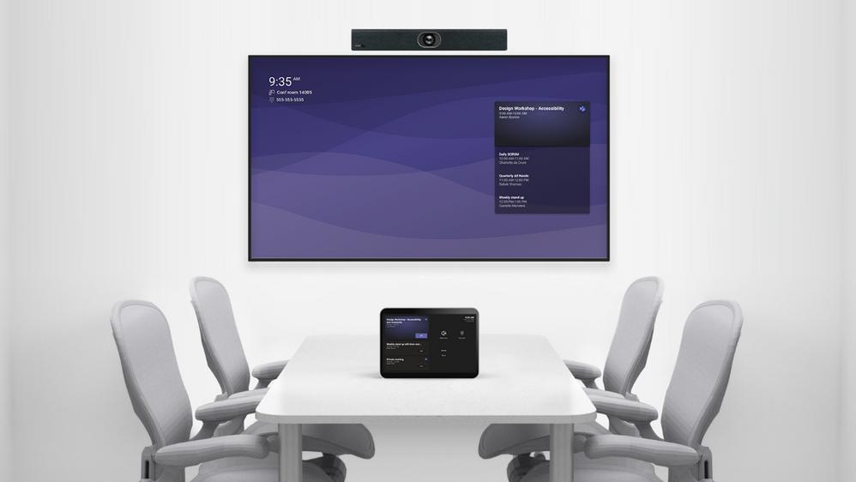

# What is Teams Rooms?

Microsoft Teams Rooms are purpose-built calling and meeting solutions that deliver a native Microsoft Teams experience with HD audio and video on Teams-certified hardware from Microsoft and their partners.

Hybrid meetings will be a requirement for many organisations, including our own, going forward. Teams Rooms provides a quick, seamless connection for those in the physical meeting room and those joining via Teams.

Previously, a meeting space may have had a PC available for attendees to log on to, from which they could then access Teams and connect to a meeting where people would be joining remotely. As you will be aware, logging on to a PC can take anything from 30 seconds to a few minutes as it loads your profile on the machine. If you have a meeting space booked for an hour you need to utilise that time effectively. Those joining remotely for a 9am meeting will be connected at 9am while you are in the room waiting to log on, this is where Teams Rooms enables the instant seamless connection as soon as you walk into the meeting space.

This guide provides an overview of the equipment which makes up a Teams Room solution, as well as how you can book/invite a device to a meeting, and how you then join the meeting and control the meeting when in the physical meeting space.

**IMPORTANT NOTE**

**PLEASE DO NOT SWITCH OFF THE TEAMS ROOM DEVICE AT ANY TIME**

Your Teams Rooms device is scheduled to check for updates at 2am every night. If updates are found they will be automatically applied. If the device is switched off, then the updates will not be applied and you may have issues when using the device the next time it is powered on. Please leave the power on.

Your device will automatically enter sleep mode after a period of inactivity. When a person enters the room the device will wake up and you can join your meetings.

# The Equipment

The equipment that makes up a Teams Room solution can vary as it all depends on what is right for the size of a meeting room space. However, all our Tyne and Wear Archive and Museum meeting spaces have a very similar setup. The image below details what you will see in the meeting space.

1. TV – 75” to 85” display screen
2. Soundbar – Providing the best audio output to those in the meeting space
3. Camera - Featured 4K sensor and 12x optical zoom. Auto framing enables the camera to recognise attendees and frame everyone automatically in the most appropriate view in rooms of any size.
4. Microphones - The Yealink array microphone supports a 20ft (6-meter) / 360° voice pickup range and works with the soundbar together to guarantee a high-quality audio solution.
5. Touch Panel – Used to join meeting and manage meeting as required

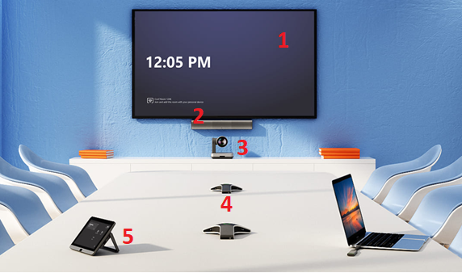

# Invite a Teams Room Device to a Meeting

The first step to a successful hybrid meeting using Teams Rooms is inviting the device to the meeting in the same way you would invite a person to your meeting.

Each device has been named and can be found in the Outlook address book, device names and locations of each device can be found below.

|  |  |
| --- | --- |
| **Location** | **Outlook Address Book Device Name** |
| Turbinia Meeting Room, Discovery Museum | Discovery - Turbinia - Teams Room |
| 4th Floor Meeting Room, Discovery Museum | Discovery - 4th Floor - Teams Room |
| Classroom, Discovery Museum | Discovery - Class - Teams Room |
| Function Room, Laing Art Gallery | Laing - Function - Teams Room |
| Learning Room, Hatton Gallery | Hatton - Learning - Teams Room |
| Workshop, Shipley Art Gallery | Shipley - Workshop - Teams Room |
| Meeting Room, South Shields Museum | South Shields - Meeting - Teams Room |
| Corder Room, Segedunum | Segedunum - Corder - Teams Room |
| John Storey Room, Stephenson Railway Museum | SSR - John Storey - Teams Room |
| Staff Meeting Room, Great North Museum | GNM - Meeting - Teams Room |

1. Create your meeting invitation as normal
2. From the address book find the room device associated with the room you have booked for your meeting  
     
   OR  
     
   Begin typing the device name in to the To box
3. Add the device as an attendee to the meeting  
   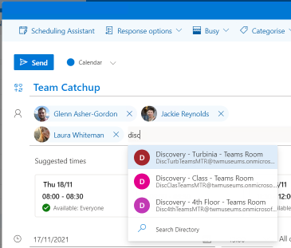
4. Send the meeting invitation to the attendees and room device as normal
5. If the device is available for the requested date and time you will receive a confirmation email, if it is not free you will receive an unsuccessful booking email notification.

**Please note:** You can use the Scheduling Assistant as normal to ensure devices are free before sending the appointment.

**Zoom Meetings Using Teams Rooms**

If you have been invited to a Zoom meeting, or you are scheduling a Zoom meeting, you can still use the Teams Rooms device in a meeting space.

In order for the Teams Room device to be invited, simply forward the meeting invitation from your TWAM account to the required meeting room.

The meeting will display on the Teams Room console and you can join the Zoom meeting in the same way as you would a Teams meeting.

# Join the Meeting in the Room

When a Teams Room device has been invited to a meeting, the associated Touch Panel in the room will display a list of meetings for that day as displayed below.

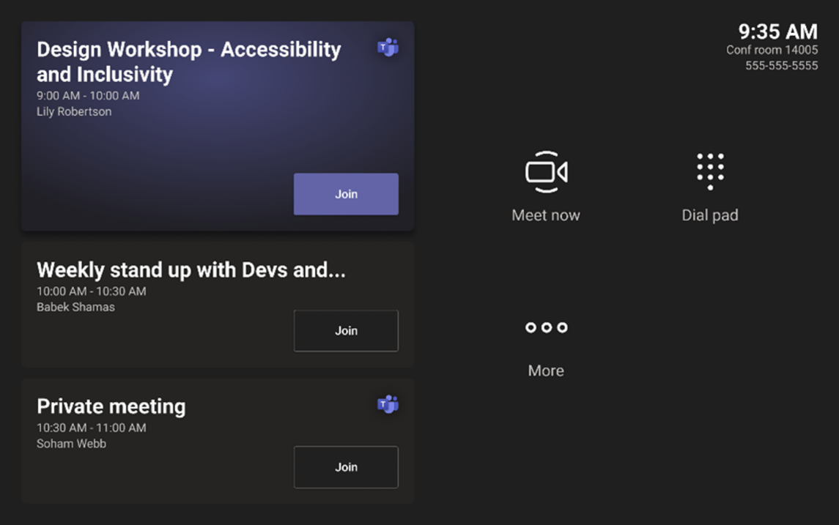

1. To join the meeting, tap the Join button on the display  
     
   The camera and microphones in the room will activate and you will now be in your meeting, any attendees joining virtually will display on the TV screen.
2. You can control the meeting from the tablet if required, the interface can be seen below

thumbnail image 4 of blog post titled 
 
 
  
 
 
 
    
  
   
    
      
       Microsoft Teams Rooms on Android | April 2021 Updates
       
      
     
   
  
 
   
 
 
 
 
 


# Start an Unscheduled Meeting

A Teams meeting can be started using the console device even if the meeting has not been scheduled to the room.

1. Select Meet now button on the room console  
   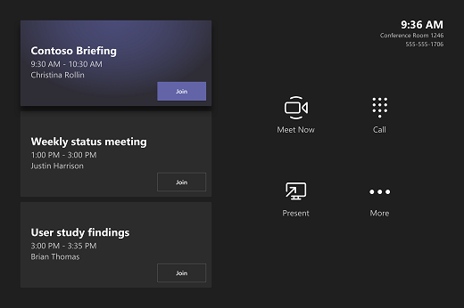
2. Under Type a name or number, find the people you want to invite.
3. After all the people you want to invite are on the list, select Invite. Your meeting will begin automatically.

# Share Content During a Meeting

There are two ways to share content from your laptop so people in the room can see your content on the screen as well as those joining virtually.

1. Join the meeting on your laptop and select Share screen button, then the item you want to share.  
     
   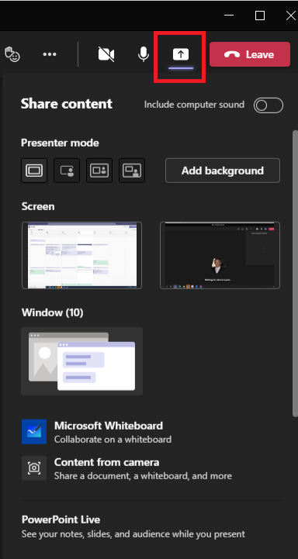  
     
   OR
2. Connect your personal device to the cable connected to the room console. Depending on your room settings, your screen may be shared automatically, or you may have to select Share screen button on the room console.

# Manage a Meeting

There are various tools available to help you manage a meeting when using Teams Room devices.

## **Add a participant**

You may want to bring someone into a meeting who was not an original attendee, you can add participant at any team using the console device.

1. Go to Add participants Add people to team button and find the people you want to invite.
2. Select people to add them to the list of invitees.
3. After all the people you want to invite are on the list, select Invite.

## **Pin a participant's video**

When there are multiple people sharing video in a meeting and you want to see one person’s video on your room display, select their name on the room console, then Pin.

Please Note: This will only pin the video for the room, not for others in the meeting

## **Remove a participant from the meeting**

To remove someone from a meeting, select their name on the room console, then Remove participant.

## **Manage the screen layout**

Select Layout on the room console.

There, you can toggle between different layouts for your room display.

## **Manage audio**

Select Mic Mute button on the room console to mute or unmute the room mic.

Select Volume up or Volume down to adjust the speaker volume or mute the speaker.

Please Note: You can also mute and control volume by pressing the associated buttons on the microphones on the meeting table

Mute participants by going to Participants, selecting a name, and then Mute participant.